

**Infulytics’ *FamilyConnect* Application:**

**Improving patient outcomes one healthcare family at a time**

Brief Description of FamilyConnect Platform (landing page):

FamilyConnect is a platform designed to give patients a user-focused tool to track their postoperative pain experience. Patients are asked a short survey regarding their pain experience. Through this platform, patients are able to input, track and share their progress with their healthcare providers and loved ones. This information can be used by patients to more effectively communicate with their healthcare providers about their postoperative pain management needs and facilitate shared decision making. This information can also be shared with loved ones to support patients in their recovery journey.

FamilyConnect is a **patient-centered** platform. This platform focuses on providing a patient interface that promotes high-value feedback while minimizing the burden on the patient. Through FamilyConnect, patients can seamlessly provide their data daily in less than 30 seconds a day.

Using the FamilyConnect platform is easy. Patients are not required to download an application on their phone or logon onto a website and create a password. Patients are simply asked to follow a few short prompts after scanning a QR code with their smartphone camera during the first use of the platform. After that, patients are prompted via text or email to complete the survey. This simplified process improves patient adherence and satisfaction with the use of the FamilyConnect.

The FamilyConnect platform allows healthcare providers to **empower patients.** Through this platform, patients can communicate with providers regarding their pain management, leading to shared decision-making for improved patient satisfaction and likelihood of improved outcomes. FamilyConnect does not require integration with the local EHR, but encourages this patient to share their information with their provider.

Comprehensive data sets – including robust patient-reported outcomes (PRO) data – are needed to better understand the impact of clinical interventions, and support the transition of U.S. healthcare from a fee-for-service to a value-based model.

Refractory post-operative pain is well established factor in driving 30-day hospital ED visits and readmissions.[1] [2] Improved perioperative pain management strategies may help reduce these surgical readmissions, which are utilized as a quality measure in many institutions.

Indwelling peripheral nerve catheters are widely used following orthopaedic surgical procedures, in an effort to reduce opioid use and improve perioperative pain management.[3] These catheters have been shown to improve pain management in orthopaedic surgery.[4] Catheters that use electronic infusion pumps with intermittent bolus function in addition to patient-controlled bolus can further improve the efficacy of pain management, compared to continuous peripheral nerve catheters alone.[5] A recent study found that patients were highly satisfied with their pain management after elective orthopaedic procedures when provided with an indwelling peripheral nerve catheter with an infusion pump that had programmed an intermittent bolus function.[6]

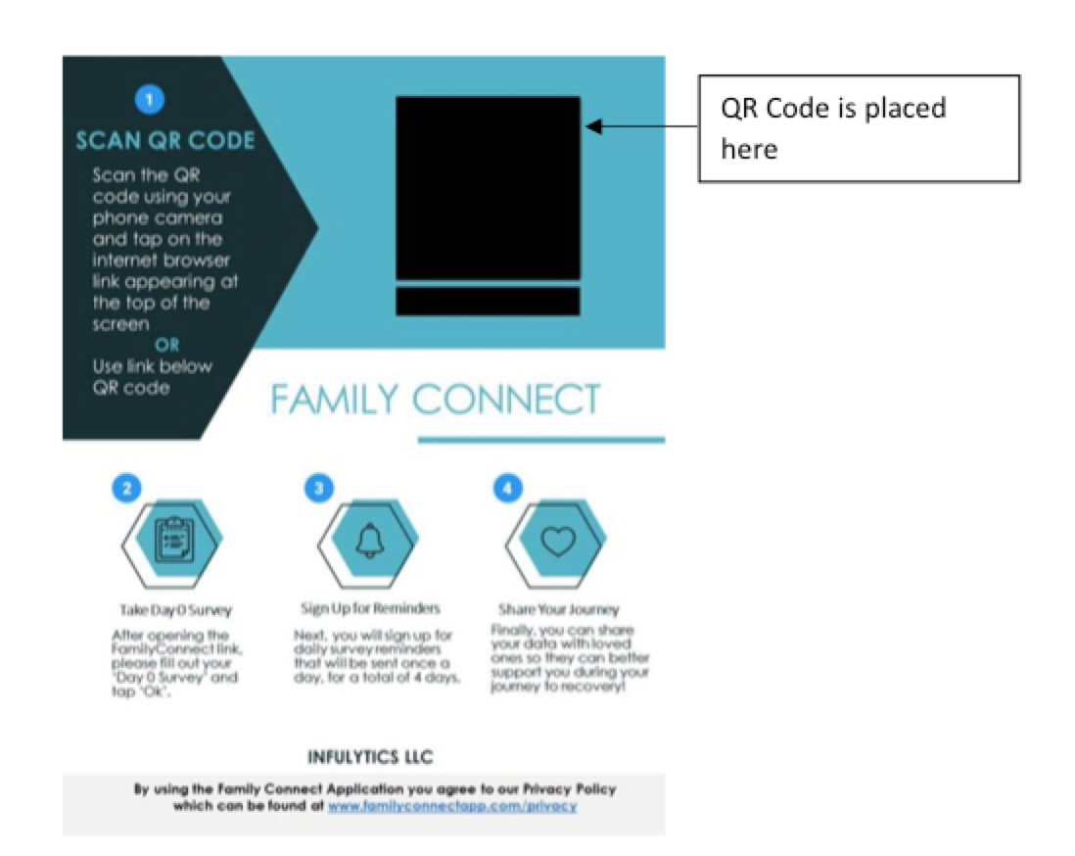InfuLytics’ new application, FamilyConnect, is designed to collect scalable PRO data, with the core objective of improving the perioperative value equation. Our initial focus is on indwelling peripheral nerve catheter use and postoperative pain management following orthopaedic surgery. A registry is in place, with multiple academic and private practice partners already contributing data.

**The FamilyConnect workflow**

As the initial step in the workflow for the application, the patient or caregiver scans a QR code and is taken to a web-based interface. Here, they enter demographic information, and are asked to fill out a validated five-question survey about their postoperative pain experience, each day for five days. After their first use of the platform, patients are prompted via text, email or calendar invitation to complete subsequent surveys. This simplified process – which takes less than 30 seconds a day – improves patient satisfaction with the application and adherence with the survey protocol.

***Benefits to patients***

This patient-centric application empowers individuals to share their postoperative pain experience with their healthcare providers, driving more effective communication and helping improve pain management post-discharge. This information can also be shared with caregivers and others involved in supporting the patient’s recovery.

***Benefits to providers***

FamilyConnect sends patient-level data back to providers electronically through an interactive dashboard that leverages an advanced visual analytics solution. Our proprietary data delivery strategy helps providers gain actionable insight on patient progress following catheter placement, and improves the overall care experience for both patients and providers.

***HIPAA compliant***

FamilyConnect partners with Amazon Web Service (AWS) to deliver fully HIPAA compliant data provisions, with all protected health information (PHI) secured in compliance with applicable regulations.[7] The only personal data that may be collected by the app is a phone number or email address, and patients can opt out if they prefer to use a calendar invitation for subsequent survey reminders. FamilyConnect does not require integration with a local EHR.

***IRB exempt***

The FamilyConnect app is part of a quality improvement initiative, and as such has been determined by Western Institutional Review Board, an independent review board, to be exempt from IRB approval. Full documentation is available for customers wishing to provide details to their institutional IRB.

***Get involved***

Contact us to learn more about FamilyConnect and how we can support your institution’s quality improvement initiatives.

***References***

1. Hernandez-Boussard T, Graham LA, Desai K, et al. The Fifth Vital Sign: Postoperative Pain Predicts 30-day Readmissions and Subsequent Emergency Department Visits. *Ann Surg.* 2017;266(3):516-524. <https://www.ncbi.nlm.nih.gov/pubmed/28657940>
2. Shibuya N, Patel H, Graney C, Jupiter DC. Factors associated with emergency room visits within 30 days of outpatient foot and ankle surgeries. *Proc (Bayl Univ Med Cent)*. 2018;31(2):157–160. Published 2018 Apr 11. doi:10.1080/08998280.2018.1441251

   <https://www.ncbi.nlm.nih.gov/pmc/articles/PMC5914482/>
3. Rajeev A, Tumia N, Karn K, Kashyap S, Mayne D. Postoperative pain relief and functional outcome following total knee arthroplasty - a prospective comparative audit of three analgesic regimes. *Acta Orthop Belg.* 2016;82(2):265-270. <http://actaorthopaedica.be/assets/2685/16-rajeef-.pdf>
4. lfeld BM. Continuous Peripheral Nerve Blocks: An Update of the Published Evidence and Comparison With Novel, Alternative Analgesic Modalities. *Anesth Analg.* 2017;124(1):308-335. <https://www.ncbi.nlm.nih.gov/pubmed/27749354>
5. Joshi G, Gandhi K, Shah N, Gadsden J, Corman SL. Peripheral nerve blocks in the management of postoperative pain: challenges and opportunities. *J Clin Anesth.* 2016;35:524-529. <https://www.ncbi.nlm.nih.gov/pubmed/?term=Peripheral+nerve+blocks+in+the+management+of+postoperative+pain%3A+challenges+and+opportunities>
6. Horn ME, Hopkins TJ, Luke C. The association between indwelling peripheral nerve catheter use and postoperative pain management following orthopaedic surgery. Abstract. American Society of Regional Anesthesia (ASRA) Annual Regional Anesthesiology & Acute Pain Medicine Meeting (2019?)
7. <https://cybersecurity.att.com/solutions/hipaa-compliance-solution>